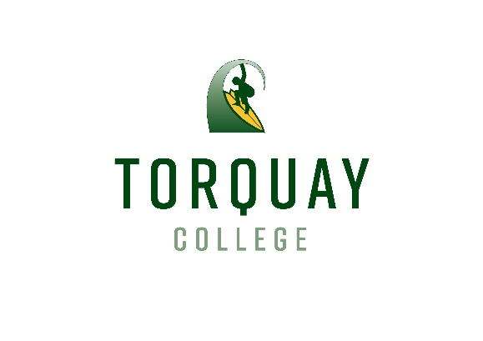
Torquay College Child Safety Code of Conduct :
To promote child safety in the school environment we acknowledge the following:
All students have a right to:
• Take part in learning programs that meet their individual needs.
• Feel secure and to be safe in a caring and supportive environment.
• Work and play without interference in an atmosphere of harmony and cooperation.
• Receive respect, kindness and courtesy and to be treated with fairness.
• Have learning continue without disruption in a supportive environment.
• Be valued for their individuality including; race, gender, cultural, physical or intellectual
diversity.
• Expect the school rules are fair, consistently implemented and respect the rights of all
involved.

All students have a responsibility to:
• Care and value themselves, others, teachers and the school community.
• Be safety conscious in relation to themselves and others.
• Treat others with respect and good manners.
• Keep the guidelines of good behaviour, modelling and supporting school rules.
• Develop a sense of accountability for their own actions.
• Work to achieve their personal best whilst allowing others to do the same.
• Allow for others to learn and to respect the rights of others.
• Explore their full potential in their learning.

School staff adheres to the following standards about the ways in which school staff are expected
to behave with children:
• School staff provide opportunities for all students to learn
• School staff treat their students with courtesy and dignity
• School staff work within the limits of their professional expertise
• School staff maintain objectivity in their relationships with students
• School staff are always in a professional relationship with the students in their school whether at school or not

